Project Design Phase-II
Data Flow Diagram & User Stories

Date | 26 June 2026
Team ID
Project Name | Automated Network Request Management
Maximum Marks | 4 Marks

Data Flow Diagrams: A Data Flow Diagram (DFD) is a graphical representation of the flow of information within the Automated Network Request Management System. It illustrates how network service requests are submitted by users through the ServiceNow Service Portal, processed by the system, validated, approved, assigned to network engineers, and fulfilled. The DFD clearly depicts how data enters the system, how it is transformed through various processes, where it is stored in the custom tables (u_network_database and u_network_task), and how it flows between employees, managers, network engineers, and the ServiceNow platform. A well-designed DFD provides a clear understanding of the system's functionality, improves communication among stakeholders, and serves as an effective tool for analyzing, designing, and documenting the automated network request management process.

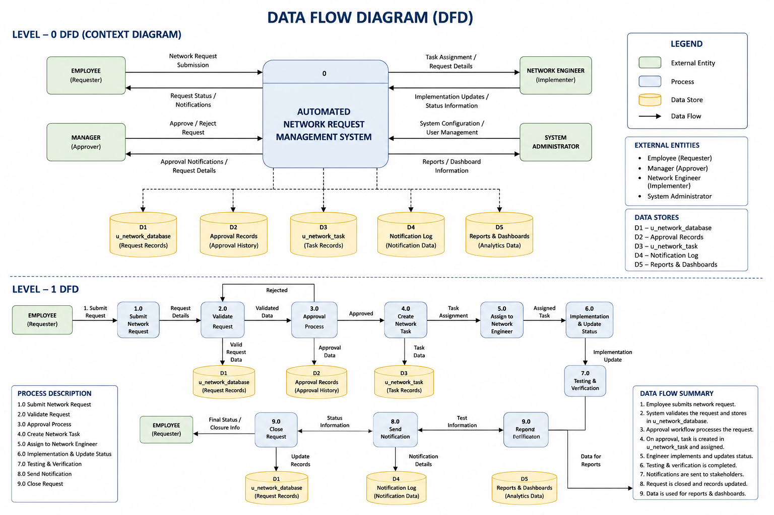

User Type | Functional Requirement (Epic) | User Story Number | User Story / Task | Acceptance Criteria | Priority | Release
Employee (Requester) | User Authentication | USN-1 | As an employee, I can log in to the ServiceNow portal using my authorized credentials to access network services. | I can successfully access the Service Portal. | High | Sprint-1
 | Network Request Submission | USN-2 | As an employee, I can submit a network service request by selecting the required service and entering the necessary details. | I can create and submit a network request successfully. | High | Sprint-1
 | Request Tracking | USN-3 | As an employee, I can track the status of my submitted network requests in real time. | I can view the current request status and progress. | High | Sprint-2
 | Email Notifications | USN-4 | As an employee, I want to receive email notifications whenever my request status changes. | I receive notifications for request submission, approval, rejection, and completion. | High | Sprint-2
 | Request History | USN-5 | As an employee, I can view all my previously submitted network requests. | I can access my request history from the portal. | Medium | Sprint-3
Manager (Approver) | Request Approval | USN-6 | As a manager, I can review network requests and approve or reject them based on organizational policies. | I can approve or reject pending requests. | High | Sprint-2
 | Approval Comments | USN-7 | As a manager, I can provide comments while approving or rejecting a request. | Comments are saved with the approval record. | Medium | Sprint-2
Network Engineer | Task Management | USN-8 | As a network engineer, I can receive automatically assigned implementation tasks after request approval. | I can view assigned network tasks in my work queue. | High | Sprint-2
 | Request Implementation | USN-9 | As a network engineer, I can update task progress and implementation details until completion. | Task status and implementation notes are successfully updated. | High | Sprint-3
System Administrator | Workflow Automation | USN-10 | As a system administrator, I can configure workflow automation, approvals, and assignment rules for network requests. | The system automatically routes requests according to configured workflows. | High | Sprint-3
 | Dashboard & Reports | USN-11 | As a system administrator, I can generate reports and dashboards to monitor network request performance. | Reports and dashboards display accurate request metrics and analytics. | Medium | Sprint-3
 | Role-Based Access Control | USN-12 | As a system administrator, I can manage user roles and permissions to ensure secure access to the application. | Users can only access modules and records based on their assigned roles. | Medium | Sprint-3

